LEMBAR JAWABAN TUGAS HARIAN
PROGRAM STUDI ILMU KOMPUTER
UNIVERSITAS DJUANDA
 | NIM : I.2210191  …………………………………………………………….......................  Nama Mahasiswa : Muhammad Rival Pratama  ………………………………………………………………………………….  Semester : Semester 4  …………………………………………………………………………………. | NILAI :

Jawaban :

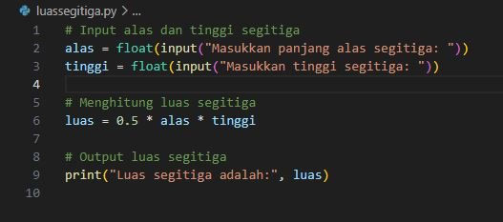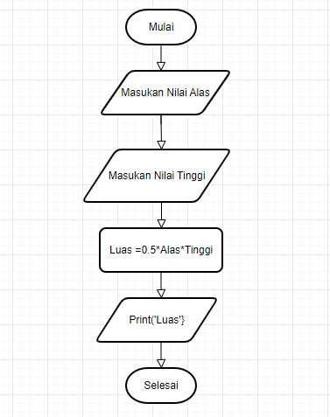

2.

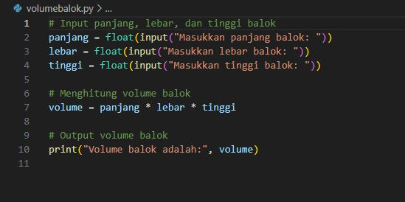

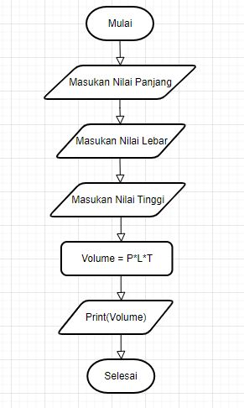

3.
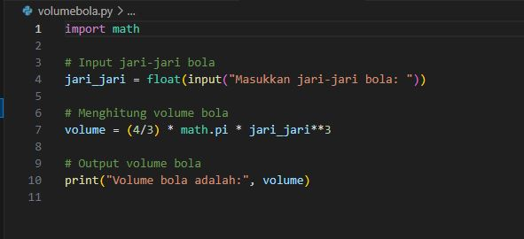

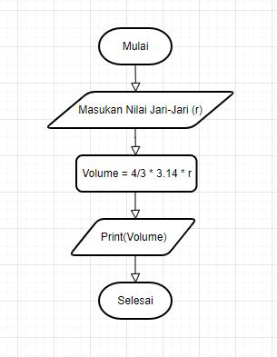

4.
